**CIS-350  
Infrastructure Technologies**

**Lab 2 Report**

**Student Name**: **Regis Wilson**

**You must use this template to hand in Lab 2 Report.**

1. Insert *Lab2_Tree* file from p. 8 of the Lab 2 instructions into the space provided or use the *Alt-PrtScr* keys to capture the screen output (window) from command *TYPE Lab2_Tree* on p. 8 and paste that window here.

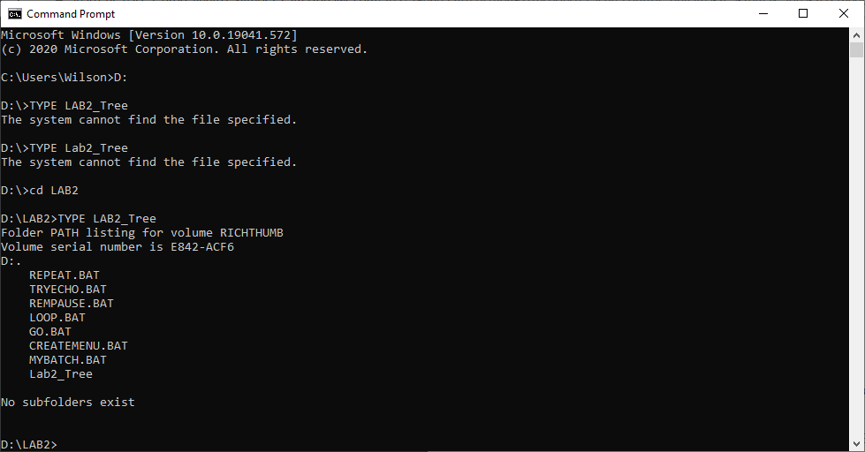

1. Assume that the system prompt displays "C:\>", i.e., your current directory and current drive are the root directory and C drive, respectively. Write a batch file below that will include commands to:
2. prevent all commands from displaying on the screen. Also, disable command ECHO OFF from displaying.
3. display the following message "My first script file"
4. display the directory hierarchy/structure of the C disk (Do not use DIR)
5. display the directory hierarchy/structure of the C disk with all files (Do not use DIR)
6. create subdirectory named *LETTERS* in the root directory
7. erase subdirectory *BOOKS* from the root directory (assume that *BOOKS* does not have any files in it)
8. copy file *loop.bat* to directory *LETTERS*
9. pause the screen
10. use the piping operation to display the sorted directory and display it one screen at a time (prevent the screen from scrolling off). Need to use two pipes.
11. sort data in the descending order coming from file *Names1* and route the output to file *Names1_Sorted*

The batch file, commands (a) through (j):

**@ECHO OFF**

**REM My First Script File**

**TREE**

**TREE /F**

**MD LETTERS**

**RD BOOKS**

**COPY loop.bat \LETTERS**

**PAUSE**

**DIR | SORT | MORE**

**SORT /r < Names1 > Names1_Sorted**

1. Describe step by step what a file named MYSCRIPT does.

@ECHO OFF

REM STARTING SCRIPT FILE

TREE /F

PAUSE

DIR

PAUSE

MD HANK TOM LISA

TREE /F

PAUSE

COPY *.BAT D:\LAB2\LISA

TREE /F

TREE

PAUSE

CD LISA

ERASE *.BAT

PAUSE

CD ..

TREE /F

PAUSE

RD HANK TOM LISA

TREE /F

PAUSE

REM CLOSING SCRIPT FILE

Assumptions: The prompt D:\LAB2> is displayed. D is the current drive and LAB2 is the current directory just below "\" (the root directory).

|  |  |
| --- | --- |
| **Command** | **Description (Fill in)** |
| **@ECHO OFF** | Doesn’t allow any commands to appear on the screen and since the @ is there it prevents the command “ECHO OFF” from displaying as well. |
| **REM STARTING SCRIPT FILE** | On the screen the remark “STARTING SCRIPT FILE” will be displayed. |
| **TREE /F** | The hierarchy of the directory within the current directory (LAB2) and below it will be displayed. |
| **PAUSE** | To see how the previous command affected everything, the “PAUSE” command pauses the screen until a key is hit such as the space bar. |
| **DIR** | Displays the directory and its contents. |
| **PAUSE** | To see how the previous command affected everything, the “PAUSE” command pauses the screen until a key is hit such as the space bar. |
| **MD HANK TOM LISA** | Makes/creates three new subdirectories titled HANK, TOM and LISA in the directory LAB2. |
| **TREE /F** | It will display the hierarchy of the directory with all of the files in the current directory and below it. It will also have the three directories created above. |
| **PAUSE** | To see how the previous command affected everything, the “PAUSE” command pauses the screen until a key is hit such as the space bar. This essentially stops the execution of the batch file until the user hits a key. |
| **COPY *.BAT D:\LAB2\LISA** | This will copy all of the files with the .BAT ending from the current directory to the directory LISA that was created earlier. |
| **TREE /F** | It will display the hierarchy of the directory with all of the files in the current directory and below it. The batch files in directory LISA will also be seen too. |
| **TREE** | It will display the hierarchy of the directory with all of the files in the current directory and subdirectories below it. There are no files in the subdirectories to be shown. |
| **PAUSE** | To see how the previous command affected everything, the “PAUSE” command pauses the screen until a key is hit such as the space bar. This essentially stops the execution of the batch file until the user hits a key |
| **CD LISA** | Changes the directory (LAB2) to the directory LISA. It then should read “D:\LAB2\LISA>”. |
| **ERASE *.BAT** | This would erase all of the files with the ending “.BAT” from the directory LISA. |
| **PAUSE** | To see how the previous command affected everything, the “PAUSE” command pauses the screen until a key is hit such as the space bar. This essentially stops the execution of the batch file until the user hits a key |
| **CD ..** | This command returns to the parent directory which is LAB2. |
| **TREE /F** | It will display the hierarchy of the directory with all of the files in the current directory and below it. Since we deleted the batch files in the directory LISA they should not be there. |
| **PAUSE** | To see how the previous command affected everything, the “PAUSE” command pauses the screen until a key is hit such as the space bar. This essentially stops the execution of the batch file until the user hits a key |
| **RD HANK TOM LISA** | This would cause for directories HANK, TOM, and LISA to be removed from the parent LAB2 directory. |
| **TREE /F** | It will display the hierarchy of the directory with all of the files in the current directory and below it. Since we removed the three directories earlier, they should not appear in the LAB2 directory at all. |
| **PAUSE** | To see how the previous command affected everything, the “PAUSE” command pauses the screen until a key is hit such as the space bar. This essentially stops the execution of the batch file until the user hits a key |
| **REM CLOSING SCRIPT FILE** | This would display the remark CLOSING SCRIPT FILE on the screen. |

1. Optional. Briefly describe any issues with the lab. Point me to the specific pages and suggest changes. Thanks.